Cinema and architectural design education

ABSTRACT
This research focuses on revealing the contribution of cinema movies to understanding design ideas and stimulating student cooperation in architectural design education procedure. The topic is based on the use of cinema films as a methodological tool in architectural design education leading to the comprehension of the meaning in space production and architectural design. It is suggested that the film’s “truth” coincides with the designer’s “truth” as they are both subjective and are communicated to their potential viewers or users. They both use visual and functional qualities for creating spaces that do not pre-exist. Through these paths and similarities, it can be argued that the cinema image can alter and enrich the vision of a designer.
Keywords - Cinema and design, architectural design education, architectural design ideas, space perception.

Introduction
This paper focuses on revealing the contribution of cinema movies to understanding design ideas and stimulating student cooperation in architectural design education procedure. Since the architectural picture has a “narrative” power and so do cinema images, educational methods in design could conveniently “mirror” theoretical aspects in this designing procedure, through the mediation of cinema. Thus it is suggested, that within the educational procedure of obtaining knowledge through interdisciplinary approaches, cinema films could be used as a “discovering” process to architectural design education. If cinema can produce cultural products and these products can affect perspectives, spread and alter them on a worldwide level through the immediacy of the image, then film sets must have the power to affect and reformulate the empirical approaches to space, defining choices in style, form, function and construction.
The research methodology suggested can be used in architectural design education as the constructed cinema space, functions as a concentrated experience for an audience, where educational procedures (in their lives) lead them to an easier evaluation of space through sight and through the activation of their other senses. The ground remains open to interpretation and use; it depends on the professors to select from the “tank” those elements that will support visually and mentally the educational goals and subjectivity of creative design. The presentation of the selected movie scenes relating to office spaces is only indicative, as these elements seem to be inexhaustible and productive.

2. The image and the cinema
When Noel Burch (1969) mentioned that any movie is a sequence of time-pieces and space-pieces, he recognized that cinema manufactures pre-established space-time relationships that function as a narrative, which transpires a key-role in a film’s story perception. On the other hand, Giles Deleuze (1990) ignoring the general theory of relativity, separated the “movement image” from the “time image”, for the second, in his point of view, functions in a Newtonian Universe where time is disconnected from movement, and “relations of time (in the image) cannot been seen in the represented object and do not allow themselves to be reduced to the present”. Arnold Hauser (1999) indicated that the difference between cinema and other arts is the fact that the boundaries of space and time are fluid – space has a quasi-instanenous time frame, which to some extent acquires a spatial character, so that space loses its static quality, its serene passivity and becomes dynamic; it comes into being as it were before your eyes. Finally Antony Vidler (2007) suggested that film and architecture are connected since modern architecture “operated as a psychic mechanism, constructing its subject in space and time” and so does cinema.
This paper focuses on revealing the contribution of cinema movies to understanding design ideas and stimulating student cooperation in architectural design education procedure. Since the architectural picture has a “narrative” power and so do cinema images, educational methods in design could conveniently “mirror” theoretical aspects in this designing procedure, through the mediation of cinema. Thus it is suggested, that within the educational procedure of obtaining knowledge through interdisciplinary approaches, cinema films could be used as a “discovering” process to architectural design education. If cinema can produce cultural products and these products can affect perspectives, spread and alter them on a worldwide level through the immediacy of the image, then film sets must have the power to affect and reformulate the empirical approaches to space, defining choices in style, form, function and construction.
In contemporary times, images that are presented in cinema and mostly in television are the most important source of information and “virtual” experience, as the information offered by movies seems to be embedded into the script, and is based on imaginary events. Cinema functions, and this is commonly acknowledged, as a vehicle for ideological, social and aesthetic perspectives, and transfers the film creator’s ideas using real objects in order to construct the meaning of the movie. Andrei Tarkovsky (1986) commented that cinema images are real life’s events’ observations through time-observations expressed according to original life, retaining the norms of time factor. “The observation is selective, and in the film remains only what is rationalized as an integral part of the image”. The image in cinema movies is the main tool through which we perceive the reality constructed by its creator; the space shown there, as a reference and a memory point, leads the audience to an interpretation based on personal experience. Roland Barthes (1977) distinguishes three levels in the reading of the images: the informational level (communication), which offers the information needed for the key figures of the plot, the costumes, the spaces used, the objects and the interactions. The second level is symbolic (signification), and the third level carries the obtuse meaning of significance that signals the way it is perceived, structures the film differently, subverting the story in a manner that may not be logical but is “real” within the image’s frame.
Watching a movie, for the average viewer, is based on the use of familiar forms and circumstances, which contribute to perceiving the facts and incidents captured through the plot. The viewer, as mentioned by David Bordwell & Kristin Thompson (2006), according to the indications provided by the film as well as his previous cinematic experience, configures certain morphological and semantic expectations, makes and checks assumptions, comes to conclusions, and with his active participation builds a whole within his attempt to give meaning to a movie, in the same way that he signals his environment in everyday life. Many approaches could be included in this argument, such as “cinema has been invented in order to manipulate reality in mass’s perception” Jean- Luc Godard (1998), or “the difference between real life and reproduced life is inconsiderable” Pier Paolo Pasolini (1989). Thus no one could doubt the fact that “meanings are not found, but are constructed”, according to our social experiences and ideological convictions, as stated by Bordwell (1989). This attitude refers to the insight point of view, which differs from the semiotic interpretation, as the same author suggested. The fact that points to interpretation is an anticipatory awareness of the meaning that is meant to be discovered, and is based on the perceptions which are embedded into everyday experience, using our senses.
3. Design education
Etienne Wenger (1998) mentions that learning is a process of negotiation, people participate in and reify events together to give new meanings to things in order to reach a clearer understanding of their subject and each other. In nature, the holistic approach is constructed by way of the parts creating a whole. In design education the individual cognitional areas are theoretically connected so that organic formation of every stage is achieved, pointing students to learning through a composite procedure. In this course several commonly accepted methods are used: analysis and synthesis, descriptive and representational, interdisciplinary approaches as historical and sociological references, memory and sense, which aim for the development of authentic and creative thought. The report, recognition, perception and consolidation of knowledge, which rely on existing theoretical approaches and reflect on applied practical exemplifications, are the common ground where the academic educational methods for design are met. These methods aim at awakening originality, imagination and creativity of their recipients (S. Kavousi, P.A. Miller, 2014, J. Adams, W. Hyde, B. Murray, 2013, G.Hertnagel, T. Oravilita, 2011, N. Cross, 2004).
On the other hand incertitude, doubt and experimentation in design education are featured by many teachers as methodological tools, which combine the risk of a possible failure or success in design with interdisciplinary and multicultural values, coming to a creative procedure where fresh perspectives are contrived and different levels of reading and interpretation are unfolded (A. Domboli, A. Umbarkar, V. Subramanian, S. Domboli, 2014, T. Hadjiyianni, 2013, J. Brasset 2011, D. M. McInerney, R. A. Walker, & G. A. Liem, 2011, C H. Ho, 2001, E. Ericsson, 2001).
The important issue in design education process is that “design learning is not prescriptive when it comes to learning design there is no recipe”. Thus we have to recognize that general theoretical approaches for students, who comprehend through images and practice, and whose language is the representative tool of their design ideas, seem to be conventional and non attractive areas of concern, even though the creation of interdisciplinary substantiation of their ideas appears to exist in the project’s development.
In this paper it is suggested, that within the above active educational procedure in obtaining knowledge through interdisciplinary approaches, cinema films could be used as a “discovering” process to design education. If cinema can produce cultural products and these products can affect perspectives, spread and alter them on a worldwide level through the immediacy of the image, then film sets must have the power to affect and reformulate the empirical approaches to space, defining choices in style, form, function and construction.
This procedure is especially dynamic as it is a source of messages for active recipients, with multilevel influences – aesthetical, emotional-psychological, social, moral, etc and is connected with the production of standards and qualities, such as optical lyric, optical epic, realism, drama, magnificence, etc, which relate to style and form.
4. Cinema and architectural design
Cinema images are manufactured images - including the spaces used, and aim for an approach that reflects their creator’s ideas through the predefined performance of the characters into a whole space, which serves the script’s needs and is placed in a certain period: past historical, present contemporary, future idealistic. Time-tempus plays an important role in the experiential viewing of a movie, though different from real time, it predisposes the audience to understanding its meaning even before the introduction of the plot and the script characters.
The methodological tool for observing the cinema space, which is created according to the story, functions as a concentrated experience for an audience, where educational procedures (in their lives) lead them to an easier evaluation of space through sight and through the activation of their other senses. In fact, Maria Yfanti (2010) argues that “the audience, each time, actualizes the deconstruction of filmic space and reconstructs it”. On the other hand, as she notes “each time the audience deconstructs the sense of space and afterwards reconstructs it”. Tarkovsky (1986) mentions that “the image is not a meaning that is expressed by the film director, but it represents a whole world, which is reflected in it, as in a drop of water”.
It is of no importance if this reading gets subjective characteristics. Very often the starting point of space design procedure is based and built on subjective scenarios, which will function as real objective spaces.
The medium of the cinema film seems to be like Lewis Carroll’s book Through the Looking-Glass: when Alice passes through to the other side, she comes to realize that her imaginary living room, which was expected to be an identical reflection of the real one, is completely different in a way that:
«What could be seen from the old room was quite common and uninteresting, but that all the rest was as different as possible. For instance, the pictures on the wall next to the fire seemed to be all alive, and the very clock on the chimney-piece (you know you can only see the back of it in the Looking-glass) had got the face of a little old man, and grinned at her.».
This subjective observation of the reflected space, which is a creative construction (by its designers), outlines the common area between the cinema film and the design practice, and it is suggested that it could point to the comprehension of space forms.
Εric Rommer (1970) points to the distinction of space function into architectural, narrative and artistic, where the relation between the real and manufactured architectural spaces is examined, as well as the relation between the narrative and scenario, and the artistic elements of the image.
As it is stated by John Peponis (1997)
«Our comprehension of spatial form, as of most things, is inexorably linked to our ability to compare. At first, comparisons enable us to define the properties and characteristics of the form by formulating more or less abstract concepts. Subsequently, comparisons lead us to describe the relations and the principles that influence the making of form, the mathematical and physical restrictions that constrain it and the potential for new forms that we glean through the comparative study of morphological data».
The use of cinematic spaces, even those the story imposes stereotypical forms on, or overemphasizes their symbolic characteristics in order to support the script’s characters or even the imaginary dimensions of ideal configurations, could lead to spatial comprehension through the immediacy of the cinema picture in a visual topography. The description of the natural background in the picture, involving the materialistic aspects that characterize it, comes to a multilevel interpretive procedure: understanding the form, the social function, the cultural codes, even the historical and memorial representations; and creates the conducive ground to compare and analyze differences in size, use, period, symbolism or other, spatial forms.
Peponis (1997) notes: “constructions of space buildings contain a provisional configuration of social life”. And continues
…If we look at them from the inside, as we move, buildings become meaningful as stage sets in which our participation in this configuration or our ability to observe its outcomes can take place from different positions at the same time.
Thus it depends on the professor to select the movies that will enrich the conceptual tools of the teaching procedure, and will allow the theoretical analysis and the structure of meaning in the design procedure.
The fact that the cinema audience in this didactic practice is not a coincidental or common film audience, but is sensitive to the creative understanding of spatial references and focuses on space configuration, leads to a penetrative perception of the filmic spaces, within about the same or similar manner that real space can be observed by a moving human body, even if the observation point has been set by the film director. However this does not mean that homogenous responses are to be expected, but establishes the differences in optical perspectives through various interpretations of the thematic reading, and also signals the focusing point of the design practice.
5. The movies
Within the educational framework presented above, five movies that take place in office working spaces will be described, referring in particular to the theoretical background, the perception, the interpretation, the relevance, the typology and the historical continuity of the specific and changing functions and forms of the office spaces. The analysis, including a short reference to the story, is focused on the scenic spatial characteristics and the visual perception, aspects on which the analysis and synthetic practice are based, as well as their contribution to the educative discussion.
5.1.Metropolis
Metropolis is a German expressionist, epic, science fiction, silent film directed by Fritz Lang. Made in Germany during the Weimar Period, Metropolis is set in a futuristic urban dystopia, and follows the attempts of Freder, the wealthy son of the city's ruler, and Maria to overcome the vast gulf separating the classist nature of their city. Its value lies in the allegorical metaphors of the social conditions and on its technical achievements.
The story: in the future, wealthy industrialists rule the vast city of Metropolis with high-rise tower complexes, while another class of underground-dwelling workers’ toil constantly to operate the machines that provide its power. Metropolis is symbolically divided in two parts: the upper city where the inhuman ruler and wealthy people are placed, and the underground city where the nameless workers, identified by numbers, live among huge machines, that swallow up their lives in a repeated time frame – the 10 hour working shift. The Master of Metropolis is the ruthless John Fredersen, whose son Freder is attracted by a young woman named Maria who comes from the worker’s city. Maria is the woman-catalyst who does not conform to the machines’ power, but declares to the workers the parallelism of their city with the tower of Babel, and represents a hub role in the film’s developments and its final catharsis. After seeing Metropolis in Madrid in 1927, Luis Buñuel’s critique culminated in a passionate plea for strong ties between film and architecture: “now and forever the architect is going to replace the set designer. The movies will be a faithful translator of the architect’s boldest dreams”.
The scene selected for discussion and analysis is that where Freder appears in his father’s office, appalled by a worker’s accident. The office space is a large sized interior, where many employees are working. This space has manifold points of functional interest, as well as interesting decorative material used. (Figure 1).
John Fredersen’s office table is a curved oversized piece of furniture, representing emphatically his dominion over Metropolis; and in front of it stand two visitor’s armchairs accompanied by an equivalent coffee table with a model of the new Babel Tower- the office building, on it. (Figure 2). These pieces characterize (relatively) the space’s scale compared to the office: the oversized table, which is indentified with John Fredersen, as well as other architectural elements, such as the oversized entrance door and window through which the city is shown to its master. The furniture’s curved forms, and the step formation in front of the window, which follows John Fredersen’s desk form, are strong symbolic aspects of the office environment. These are combined with a series of futuristic machines of dynamic forms, including a board that shows production data, another token of machine power. It is also interesting to mention the absence of art pieces in this futuristic environment, which during that period were an indicator of affluence and wealth, a fact that points to the choice of materialistic symbols of dominion. The story shows the employees working under hard pressure, while John Fredersen oversees from his office space, imposing silence and stillness, even upon his son arrival. Lang’s imaginary spaces are an important interpretation of design images opposed to real life.
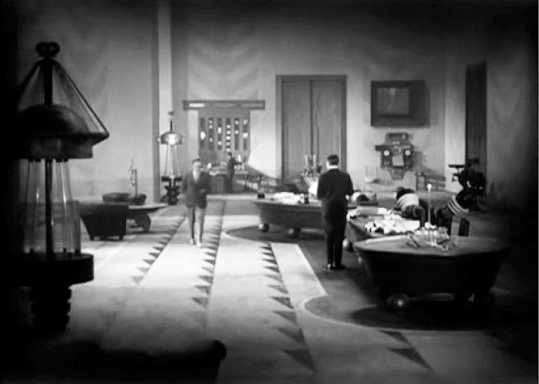
Fig. 1: John Fredersen’s office interior. Source: Metropolis (1927, dir: F. Lang).
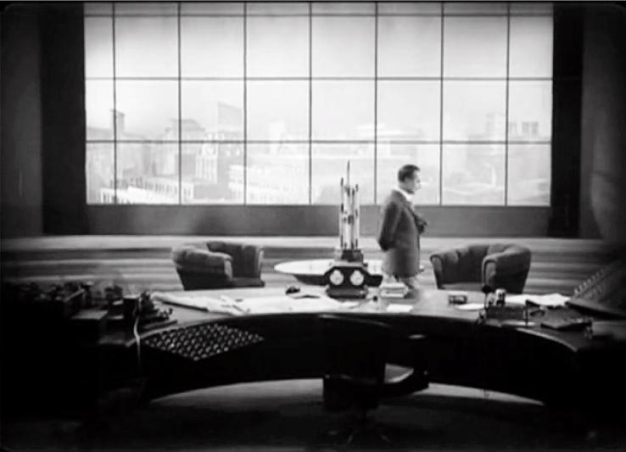
Fig 2: John Fredersen’s office table. Source: Metropolis (1927, dir: F. Lang).

The analysis highlights the office’s scale, the space and machinery design, as well as the use of materials, connecting them with the circumstances and social behaviors revealed through them. It is worth mentioning that Fritz Lang had abandoned his architectural studies in order to devote himself to cinema, however preserving the potential of space and futuristic representations, so as to feed his ideas.
5.2. Play time
Play Time is the masterpiece of French filmmaker Jacques Tati. The film was shot from 1964 to 1967. Its main character is Monsieur Hulot, who had appeared in Tati’s earlier films. In this film as in all his films, Tati depicts modernism’s problematic impact on the gray urban center of Paris, full of skyscrapers, apartment blocks, elevators, glass walls, colorless surfaces, and the way in which people interact within it. The movie’s carefully considered environment shows characteristics of the modernist movement of that time: repetition and regularity, functional and constructive standardization (as the result of industrialization), visual truth in the use of materials, which are represented both in every detailed interior space, and in the city’s urban plan. The movie is structured in six sequences linked by two characters who repeatedly encounter one another in the course of a day: Barbara, a young American tourist visiting Paris with a group composed primarily of middle-aged American women, and Monsieur Hulot, a befuddled Frenchman lost in the new modernity of Paris.
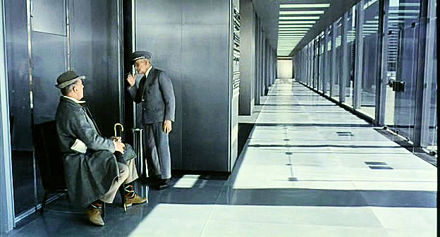
Fig. 2: The corridor and glass offices. Source: Play Time (1967, dir: J. Tati).

The reference scene is the second sequence, in which Monsieur Hulot arrives for an important meeting at the office building, a modern skyscraper made of steel and glass, with glossy surfaces and a totally neutral grey façade. In the interior space long, grey corridors lead to glass offices on both sides (Figure 3), a glass waiting hall is furnished with comfortable black leather chairs (Figure 4), a meeting place includes a long meeting table and Harry Bertoia’s side chairs. As for the working space, it is organized with repeatable, identical, cubic offices of medium height – about Monsieur Hulot’s height (Figure 5), in rows, with a façade of a short storage wall, and a telephone operator’s small rotating glass cube in the middle. He is lost in this labyrinth of rooms and offices, chasing the reflections of his rendez-vous on the glass dividing walls. The space represents an organizational system, which lies between an open plan recurrent office and a 60’s alternative organizational system called “Action office”.
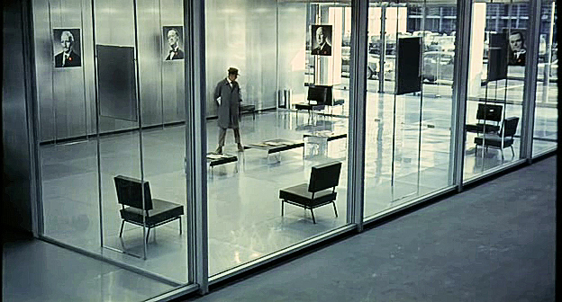
Fig.4: The glass waiting hall. Source: Play Time (1967, dir: J. Tati).

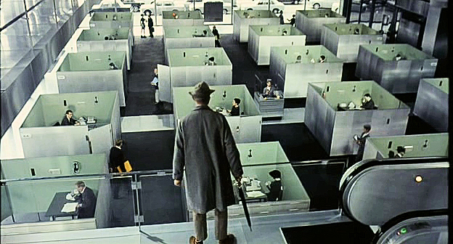
Fig.5: The cubic offices in rows. Source: Play Time (1967, dir: J. Tati).

The analysis focuses on the workplaces’ organizational systems, connecting them with historical data and modern architecture’s new forms of thinking and design, as well as with their functionality in relation to the work force: the ways that people work in offices, how they are affected by their environment, issues like interaction, privacy, communication, control and surveillance, personal initiative, personalization of the workspace.
5.3. Nine to five and Disclosure
Nine to five is an American film directed by Collin Higgins.It is the story of three women employees, Violet – the senior office supervisor, Doralee – the up-manager’s secretary and Judy who is working as a secretary for the first time after her husband’s has left her for a younger woman, taking all their savings with him. Each one of these women becomes a recipient of their supervisor Franklyn, who is a selfish, sexist and cruel man, taking advantage of his women employees’ ideas and appearance. A gender role reversal is expressed through Disclosure, an American film directed by Barry Levinson. The Seattle-based technology company Digicom is about to merge and Tom, one of the heads of manufacturing is expecting a promotion. His position and development are imperiled by a female supervisor, Meredith, who has sexually harassed him.
Analysis is focused on the architectural working environment, and the time-differences shown, as in the background of both movies an important design decade is represented (80s, 90s). The mechanical office’s development- information technologies and work patterns defined new workplaces and working styles in order to develop flexibility, team work and improve productivity. Design becomes a central aspect in this procedure. In the films, each office design, materials and colors used represent a different organizational system, image and style, working pattern and control of the human resources. Characteristic scenes for analysis are: Judie’s first day at work (Nine to Five), involving all the characters and working environment in the movie, as well as her introduction to her supervisors and colleagues, Violet and Franklyn (Figure 6); the common working space as it is at first, a neutral open plan office space, and the same space after the changes the three women have done, color-full and 60s stylish office, where the presence of plants and nature is shown (Figures 7, 8); general view of Digicom’s interior space during Tom’s entrance (Disclosure) (Figure 9). More scenes of the same movie in different offices spaces: Meredith’s office during her meeting with Tom, the president’s and co-worker’s offices, team work meeting spaces (Figure 10), conference hall, etc.
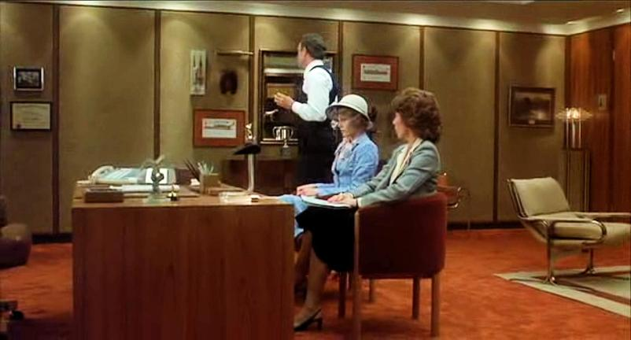
Fig.6: Flanklyn’s office interior. Source: Nine to five (1980, dir: C. Higgins).

Through this optical material the relationship between office style and hierarchical status is defined: job level is connected with office size and decoration, as well as architectural forms and symbolic structures of the interior space, to finally confer the employees’ status and rank in the administration pyramid. A second level of analysis refers to time differentiation of social conditions and attitudes: gender and office work, social stereotypes in office work, women barriers to work, organizational barriers, social roles, employment roles, etc.
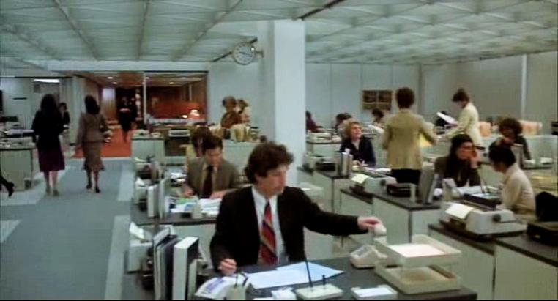
Fig. 73: The lower employees’ office interior. Source: Nine to five (1980, dir: C. Higgins).

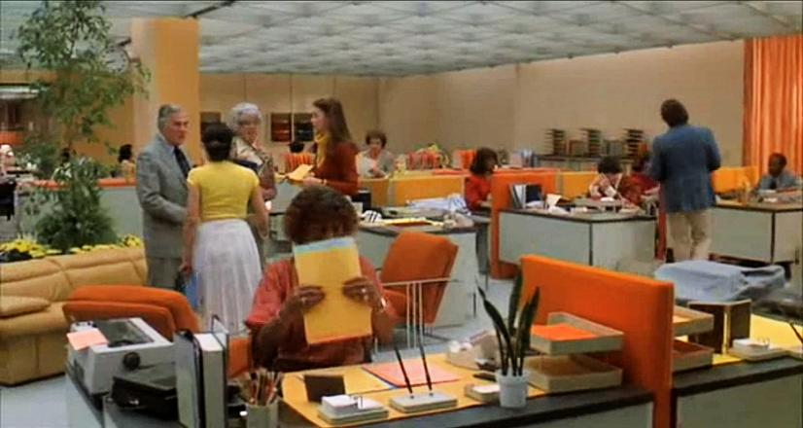
Fig.8: The same interior after the refurbishing made by the three women.

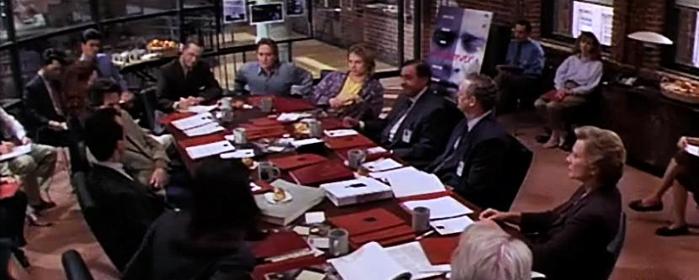
Fig.9: Team work meeting spaces. Source: Disclosure (1994, dir: B. Levinson).

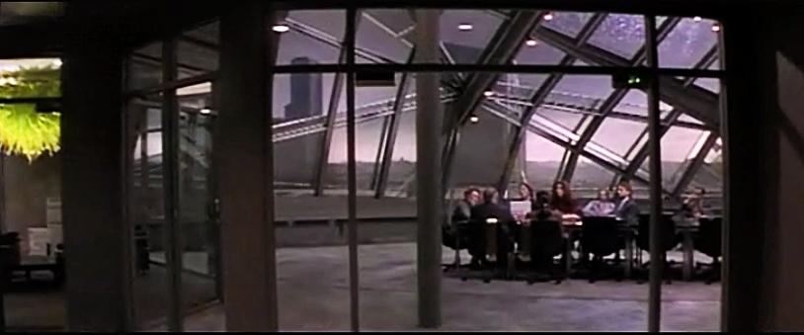
Fig. 104: Administrative meeting spaces. Source: Disclosure (1994, dir: B. Levinson).

5.4. Working girl.
Working girl is an American film created by Michael Nicols.The story is about the career evolution of a young employee Tess, within a difficult working environment. Unhappy with her job and her loser boyfriend, Tess takes a secretarial post at a major Wall Street firm. Her executive manager is Katharine, an ambitious woman who exploits Tess’s ideas. When she finds out that Katharine has actually stolen one of her ideas, Tess seizes the opportunity to steal it back by pretending she has her boss's job. Her inborn business acumen and common sense enable Tess to rise to the top of New York's financial circles, in cooperation with Jack. Things threaten to take a sorry turn when Katharine returns, but it is she who suffers from the consequences of her own past duplicity, as Tess becomes executive manager.
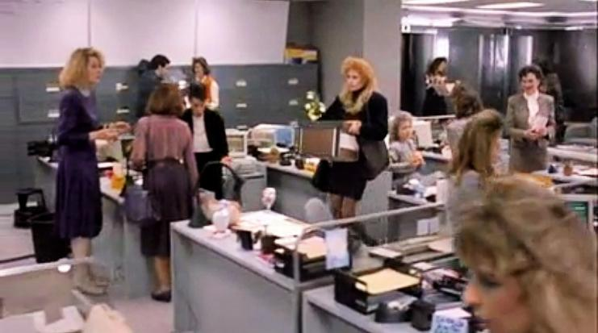
Fig. 115: Open plan office. Source: Working girl, (1988, dir: M. Nicols).

The scenes selected for analysis open the discussion on two issues – the aesthetics of the company’s image and the way that interior architecture involves traditional organizational systems in space configuration and design choices (corridor office, open plan office or landscape office system as defined by Francis Duffy 1967, 1979, 1989,1992, 1997, 1998). The scene of Tess’s first day at work as secretary and her introduction to Katharine, as well as the last scene in her new work position, describe in detail the characteristics of open plan organizational system with the noisy, depersonalized core space of several workstations for the low-paid employees (secretaries), and private personalized offices placed along external walls with windows for the executive managers (Figure 11).
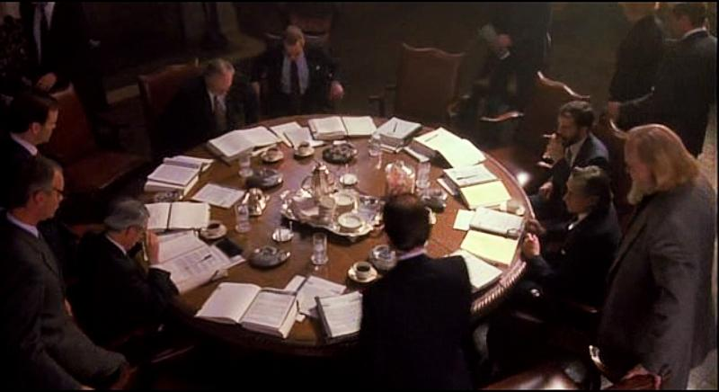
Fig.12: Aesthetics and symbolism. Source: Working girl, (1988, dir: M. Nicols).

Tess’s meeting in Dewey Company, as well as her visits to Transk Industries (Figure 12), reveals the importance of aesthetics and symbolic design choices and scenarios concerning the established company culture. The image task issue – the way the front office’s aesthetics introduce the wanted social and business climate of the company to the clients, is discussed through these scenes.
6. Synopsis
This paper focuses on revealing the contribution of cinema movies to understanding design ideas. The architectural picture has a “narrative” power and so do cinema images. Educational methods in design could conveniently “mirror” theoretical aspects in this designing procedure through the mediation of cinema. Gideon (1928) stated that cinema is the medium where modern architecture can conceptualize its ideas. Le Corbusier (1930) believed that movies were the perfect medium for representing modern architecture and that was the reason for shooting a film showing his 1920’s villas and plans for the city. Dietrich Neumann (1996), on the other hand, perceived cinema’s space as a medium that consists of “a testing ground for innovative visions, and as a realm in which a different approach to the art and practice of architecture can be realized”.
Cinema movies, among other means of visual narration, could support formal analysis in theoretical aspects and build a strong visual mechanism of understanding and communication in design education. Ideas, visions, spaces, forms and conditions in cinematography, all consist of different approaches that could challenge educators and students in generating new knowledge. In the same way experimental approaches integrate design scenarios, visual representations and creative procedures in order to answer fundamental ideas about design’s nature.
Determination seems to be the main unifying aspect in cinema movies and for different reasons unifies also design effects. Thus, the aspect defining the similarities between the two expressive means is their relationship with time. In cinema time loses its penetrative, arrow-like dimension: being concentrated it functions in support of the succession of past (flash back) and present times. So we argue for functioning in a similar way in the design and applying educational procedure. The camera’s position in a given frame and the un-continuity of cinema space, which co-exist with several viewing points, could be identified with the position of a viewer, who as a pedestrian walking along, observes the space through which he moves in a fragmentary manner and mentally connects the different views in order to construct the perception of the whole space he has walked through. The same goes for a designer, who mentally reproduces a non-continuous space, starting from his original idea to arrive to his final project, and composes a “whole” consisting of separated fragments. Within this procedure we could argue that cinema films are the imaginary vision of the real world and design is the realistic vision of imagination. The two fields (cinema and architectural design) seem to be the only visual expressive means in which the third dimension is conceptually replaced by time. In designing procedure, as well as in cinema, the two dimensions are transformed by the narration into third dimension. The movie scenes succeed each other with the camera’s movement or the continuous movement from one point to another in designing procedure in order to form the whole idea and place it in a chronic frame. The audience in cinema sits across observing realistic objects that are presented on the screen and builds the meaning of narration, which helps them understand the film’s ideas with the objects true dimension. On the other hand designers come up with their ideas to produce real projects by connecting the different phases of the creative process – from the first idea to the scenario, the drawing, the schedule, the project, and finally its use. The similar, although inverted procedure consists of a “drop” tank in which the complementary nature of the two fields allow for “loans” between them, and immediacy in their mutual use.
The use of cinema films as a methodological tool in architectural design education does not include the sentimental aspects of the audience’s involvement in the plot. It leads to the comprehension of the meaning in space production through the synthesis of visual qualities, lines, shapes, volumes, analogies, rhythms, styles and colors. And the film’s “truth” coincides with the designer’s “truth” as they are both subjective and are communicated to their potential viewers or users. They both use visual and functional qualities for creating spaces that do not pre-exist. Through these paths and similarities, it can be argued that the cinema image can alter and enrich the vision of a designer.
The evaluation of the above teaching procedure is very positive and is based on the methodology of collecting data during a period of three academic years (2011-12, 2012-13, 2013-14). The research took place within the course, which consists of lectures and project, titled “Interior Architecture and lightening: work spaces” , which is a compulsory course of the study programme of the Department of Interior Architecture, Decorative Arts and Design of Technological Educational Institute of Athens.
The teaching method included lectures as described earlier that used selected movie scenes that take place in office spaces, and discussion relating to the chosen films, so as to further analyze theoretical issues concerning these office spaces. In addition the students had to present an essay about a specific issue of their choice, using, besides bibliography, visual data from cinema movies. At the end of each of the three semesters a questionnaire with instructions as how to complete it, was given to the students, which had to be completed anomymously and returned to a student who had offered to gather the questionnaires and give them back in ten days time to the professor. (Appendix 8)
The questionnaire consists of eight close-ended (continuous) questions with five options each, three dichotomous questions and two open-ended qualitative questions, thus thirteen questions in total, as shown at the appendix. The goal was to gather answers and find out what were the students expectations, preferences and level of satisfaction, as well as the possible added value concerning the introduced method. The sample used was 244 students who completed the questionnaires out of a total of 253 students who took this course. The statistical findings are presented below.
The evaluation of the use of visual material relating to cinema movies in the teaching procedure was positive and very positive for 222 students, who represent the 90,9% of the sample (Figure 17). There were no negative evaluations. 192 students (that represent the 78,7 0% of the sample) thought that there was a clear connection between the theoretical issues of the lectures and the visual material of the cinema movies presented. There was 1 negative evaluation and 9 students that thought that this connection was weak (Figure 18). 170 students ( who represent the 70,0 0% of the sample) commended that they could understand perfectly or satisfactory issues about interior architecture through cinema movies, although 64 commended that the correlation between the two areas helped them understand only to a medium degree, 7 to a small degree and 3 that didn’t help them at all. (Figure 19). Most of the students (171/ 70%) were fully satisfied from the lecture and the rest were very and rather satisfied. (Figure 20). About 57% did not face any difficulties in following the lectures and 43% of them faced medium or small difficulties. (Figure 21). The estimated correlation of the subject area with the movies selected was very positive and positive for 65% of the students, rather positive for 27% and rather negative for 8%. (Figure 22).
The use of visual material chosen from cinema movies was helpful in writing an essay for 70% of the students, rather helpful for 28,7% of them and did not help 1,3%.(Figure 23). As for the degree of difficulty in writing their essay, most of them did not face major difficulties (53,3%), 18% faced medium difficulties; thus 28,7% find that writing their essays connecting the theoretical subject they chose with cinema movies was difficult.
To the question if the method gave them ideas and stimulate their imagination 72% answered positively and 28% negatively. About the same number answered positively (71%) and negatively (29%) to the question if they thought that the additional time spared in watching cinema movies was beneficial for their projects. Besides these, 89% of the students thought that this teaching method should continue to be used in the particular course.
The most interesting findings however are those additional values of the application that were reaped from this particular teaching method, where many described that they developed their relationships as they enjoyed watching and commenting cinema movies together. Additionally many of the students started to discover similarities between interior design and cinema.
Thus the correlation between cinema and design is spread in more fields than one, which cannot be described in this paper alone. The ground remains open to interpretation and use; it depends on the professors to select from the “tank” those elements that will support visually and mentally the educational goals and subjectivity of creative design. The presentation of the selected movie scenes relating to office spaces is only indicative, as these elements seem to be inexhaustible and productive.

7. REFERENCES

Arnheim, R., (1937). De l' Influence du Film sur le Public. Le Rôle Intellectuel du Cinéma. Paris: Institute International de Coopération Intellectuelle.
Aparicio, M., I., (2015). Film and Memory: Where do Pictures Come from in Status Also Die? In Medeiros, M., Mendes Flores, T., and Cunha Leal, J., (Ed.), Photography and Cinema, 50 Years of La Jetée; Cambridge Scholars Editor (ISBN (10):1-4438-7201-6 e ISBN: (13): 978-1-4438-7201-0), Março 2015.
Author. (2009).
Barthes, R., (1988). (Spanos G. trans). Image- Music- Text. Athens: Plethro editions. (Original work published 1977).
Bordwell, D. & Thompson, K., (2004). (Kokkinidis K. trans). Film Art: An Introduction. Athens: Educative Institution of National Bank of Greece. (Original work published 1997).
Bordwell, D., (1980). French impressionist cinema: Film culture, film theory, and film style. New York: Arno.
Bordwell, D., (1997). On the History of Film Style. Cambridge MA: Harvard University Press.
Bordwell, D., (1989). Making Meaning – Inference and Rhetoric in the Interpretation of Cinema. Cambridge, Ma: Harvard University Press.
Burch, N. (1981). (H.R. Lane trans.). Theory of film practice. N.York: Princeton University Press.(Original work published 1969).
Carrol, L. (1988). (P. Pampoudi trans). Alice Adventure in Wonderland- Through the Looking Glass, Athens: Printa editions. (Original work published 1871).
Carroll, N. (1996).Theorizing the Moving Image. USA: Cambridge University Press.
Colomina, B. (1999).The private Site of Public Memory, The Journal of Architecture, Vol. 4.
Deleuze, G. (1985). L’ image-temps, Cinema 2. Paris: Les Editions de Minuit.
Ferro, M., (2001). (Marketou P. trans.). Cinema and History: Contemporary Approaches to Film and Media. Athens: Metaixmio editions, (Original work published 1988).
Frisby, J.P., (1980). Seeing: Illusion, Brain and Mind. N. York: Oxford University Press.
Giedion, S., (1971). Architecture and the Phenomena of Transition: Three Space Conceptions in Architecture. Cambridge Mass: Harvard University Press.
Hauser, A. (1999).The social history of Art: Vol. IV , Naturalism, impressionism, the film age. N. York: Routledge.
Janser, A., (1997). Cinema and Architecture: Melies, Mallet-Stevens, Multimedia. London: BFI Publishing.
Kavousi, S. & Miller, P.A. (2014). The community of practice: Teaching Pedagogy in the Architecture Foundation Design Lab, Proceedings of EDULEARN14 Conference, 7th-9th July 2014, Barcelona, Spain.
Klein, E. Time (1995) (Koulentianou M. trans.). Athens: Travlos and Kostaraki editions. (Original work published.
Monaco, J., (2000). How to read a film: Movies, Media, Multimedia. New York, Oxford: Oxford University Press.
Neumanm, D., (1998). Introduction, Film Architecture, Set Design from Metropolis to Blade Runner. Munich, N. York: Prestel editions.
Pasolini, P.P., (1989). Letters 1940-54. Einaudi editions. (Original work published 1986).
Peponis, J., (1997). Chorographies: The Architectural Formation of Meaning. Athens: Alexandreia editions.
Robbers, L., (2012). Modern Architecture in the age of cinema: Mies Van Der Rohe and the Moving Image (Unpublished Dissertation PhD, Princeton University).
Stam, R. & Flitterman –Lewis, S., (2010). (Stamatopoulou I. trans.). New Vocabularies in Film Semiotics. Athens: Metaixmio editions. (Original work published 1994).
Steritt, D., (1998).Jean-Luc Godard: Interviews. USA: University Press of Mississippi.
Tarkovsky, A., (1987). (Velegas St trans). Sculpting in time. Athens: Nefeli editions. (Original work published 1986).
Vidler, A., (2007) Public Intimacy: Architecture and the Visual Arts. Cambridge Mass.: MIT Press, ix.
Yfanti, M., (2010). Cinematic Space and Theatrical Stage: Illusion and Convention, (unpublished MA dissertation in Aristotle University of Thessaloniki, School of Drama, Thessaloniki).
http://www.cinema sites.com
internet movie database us.imbd.com/a2z

Burch N. Theory of Film Practice, (H.R. Lane trans.), (N. York: Princeton University Press, 1981). (Original work published 1969).
Deleuze G. L’ image-temps, (Paris: Les Editions de Minuit: Cinema 2, 1985).
Hauser A. The social history of Art: Vol. IV “Naturalism, impressionism, the film age”, (N. York: Routledge, 1999), pp. 227-228.
Vidler A. “Foreword” by Giuliana Bruno, Public Intimacy: Architecture and the Visual Arts, (Cambridge Mass.: MIT Press, ix, 2007).
Tarkovsky A. Sculpting in time, (Velengas St. trans.), (Athens: Nefeli editions 1987), p.94. (Original work published 1986)
Barthes R. Image- Music- Text , (Spanos G. trans), (Athens: Plethro editions, 1988), pp 61- 76. (Original work published 1977).
Bordwell D. & Thompson K. Film Art: an Introduction, (Kokkinidis K. trans.), (Athens: Educative Institution of National Bank of Greece, 2004). (Original work published 1997).
Steritt D. Jean-Luc Godard: Interviews, (USA: University Press of Mississippi, 1998).
Pasolini P.P. Letters 1940-54, (Athens: Einaudi editions, 1989). (Original work published 1986).
Bordwell D. Making meaning – Inference and Rhetoric in the Interpretation of Cinema, (Cambridge, MA: Harvard University Press 1989), p. 7.
Kavousi S., Miller P.A. The community of practice: Teaching Pedagogy in the Architecture Foundation Design Lab, Proceedings of EDULEARN14 Conference, 7th-9th July 2014, Barcelona, Spain, p.2550.
Klein E. Time, (Koulentianou M. trans.), (Athens: Travlos and Kostaraki ed. 1997), pp. 17-18. There is an antithesis between physical time and subjective time, between the time of watches and the time of consciousness. The first which is named after the Greek word “chronos” is considered as objective, doesn’t depend on us, and is supposed to be equable. The second is defined by the Latin word tempus, rolls evenly, is the experiential or psychological time, that which is counted “inside” of us.
Yfanti M. Cinematic Space and Theatrical Stage: Illusion and Convention, MA dissertation in Aristotle University of Thessaloniki, School of Drama, (2010), p.18.
Tarkovsky A. (1987), ibid, p. 152.
Carroll L. Through the Looking-Glass, (London: 1871). p. 173.
Ibid, p. Chapter I, Looking Glass House.
Peponis J. Chorographies: The Architectural Formation of Meaning, (Athens: Alexandreia ed., 1997). p.15.
Ibid, p.166.
A pedestrian route offers to moving people different sites and space views, depending on selected observation points.
The film was written by Lang and his wife Thea von Harbou, and starred Brigitte Helm, Gustav Fröhlich, Alfred Abel and Rudolf Klein-Rogge. It was produced in the Babelsberg Studios by UFA, in 1927. Metropolis was filmed in 1925, at a cost of approximately five million Reichsmarks. It was the most expensive film ever released up to that point. Source http://en.wikipedia.org/wiki/Metropolis_(1927_film).
The Weimer republic period in Germany, started on 1919 and declined in 1933, with the beginning of Adolf Hitler’s third Reich. Metropolis is one of the last films shot, of the German Expressionists, due to its expensive budget of about 5.100.000 reichsmarks. When it was released in 1927 many cinema critics were negative because of the exaggerations it had. Bordwell D. & Thompson K., (2004), ibid, p. 498.
Dystopia is a term used in philosophy (1970) to express the opposite of utopia for the negative description of an imaginary environment focused on sociopolitical conditions. In art it is expressed in several literary works and cinema films, such as 1984 by George Orwell (1949), The blind assassin (2000) by Margaret Atwood, or Riddley Scott’s film Blade-runner(1982). The term is not yet included among accepted scientific names.
Neumanm D. Introduction, Film Architecture, Set Design from Metropolis to Blade Runner, (Munich, N. York: Prestel ed., 1998), p.9.
The film was written by Jacques Tati, Jacques Lagrange and Art Buchwald, starring by Jaques Tati, Barbara Dennek and Jacqueline Lecomte.
The sequences are as follows: the airport, the offices, the trade exhibition, the apartments, the Royal Garden and the carousel of cars. Source: http://www.archdaily.com
Harry Bertoia was an Italian modern furniture designer and sound sculptor. He studied in America and is famous for a series of five furniture pieces, among them the diamond chair, produced by F. Knoll Company and known as Bertoia’s Collection for Knoll (1950-52).
“Action office” (1964) is a series of office furniture items, designed by R. Propst and manufactured by H. Miller’s company. The design came out of a research project, as R. Propst’s academic background, had to do with the efficiency of the working environment, including the office layout and the performance of the employees, concerning communication, privacy and personal initiative. Action Office I featured desks and workspaces of varying height that allowed the worker freedom of movement, and the flexibility to assume the work position best suited for the task. Action Office II was based around the mobile wall unit that defines space. The unit also supported multiple workstation furnishings that benefited from the vertically oriented work space. The components were interchangeable, standardized, and simple to assemble and install. More importantly, they were highly flexible, allowing the company to modify the work environment as needs changed. It is known as the cubic office. http://en.wikipedia.org/wiki/Action_Office
The film was released in 1980. The script was written by Patricia Resnick and Collins Higgins, starring Jane Fonda, Dolly Parton, Lilly Tomlin and Dabney Coleman.
The film was shot in 1994. The script was based on Michael Crichton’s novel, adapted by Paul Attanasio, starring Michael Douglas, Demi Moore, Donald Sutherland, Dennis Miller and Caroline Goodhall.
The film was written by Kevin Wade, and starred Melanie Griffith, Sigourney Weaver, Harrison Ford and Joan Cusack. It was released in 1988, and many scenes were shot in well known office buildings, such as the lobby of the World trade center, which was destroyed in the 11th September attack, the state Street Plaza and the Chase Manhattan Plaza. Source http://en.wikipedia.org/wiki/Working_Girl.
Francis Duffy research is focused on office design and workplace strategy. His publications are: Duffy, F. Planning Office Space, (London: Architectural Press, 1979). Duffy, F. & Henny, A. The Changing City, (London: Bulstrode Press, 1989). Duffy, F. & Hannay P. The Changing Workplace, (London: Phaidon, 1992). Duffy, F. & Powell, K. The New Office, (London: Conran, Octopus, 1997). Duffy, F., Laing, A., Jaunzens, D., & Willis, S., New Environments for Working, (London: Construction Research Publications,1998). Duffy F., E. & Spon F. N., Huton, L. Architectural Knowledge: The Idea of a Profession, (London: Questia1998).
Janser A. Cinema and Architecture: Melies, Mallet-Stevens, Multimedia, (London: BFI Publishing, 1997), p.34.
L’ Architecture d’ aujourd’ hui was the film made in 1929, with Pierre Chenal. Colomina B. The private Site of Public Memory, in the Journal of Architecture, Vol. 4, (1999). p.335.
Neumann D. Film Architecture: Set Designs from 'Metropolis' to 'Blade Runner', (New York: Prestel, 1996), p.7.
Technological Educational Institute of Athens of Athens is a school of Higher Education, the third in Greece, with five faculties, 27 departments and more than 22.000 students. It is a legal establishment, operating under public Law, electing their own executive bodies, and fully self-governed. The Faculty of Applied Arts and Design has four departments: Interior Architecture, Decorative Arts and Design, Graphic Design and Graphic Arts Technology, Photography and Audiovisual Arts, Antiquities and Works of Art Conservation. 8.Appendix - Questionnaire 1-5 is the evaluation increasing - How do you evaluate the use of visual material coming out of cinema movies in the teaching procedure of this course? 1 2 3 4 5 - Was there a clear connection between the theoretical issues of the lectures and the visual material of the cinema movies presented? 1 2 3 4 5 - Did the correlation between interior architecture subject area and the movie subject area help you to understand the theoretical issues discussed during the course? - 2 3 4 5 - Choose the level of satisfaction from the lectures compared to ordinary lectures. 1 2 3 4 5 - Choose the level of difficulty in following lectures. 1 2 3 4 5 - The estimated correlation between the subject area and the movies selected. 1 2 3 4 5 - Did the use of visual material chosen from cinema movies help you in writing your essay? 1 2 3 4 5 - What was the level of difficulty you faced in writing your essay? 1 2 3 4 5 - Did the method give you ideas and stimulate your imagination? Yes No - Do you think that additional values of the application were reaped from this particular teaching method? If yes describe them. Yes No - Do you think that the additional time spared in watching cinema movies was beneficial for you project? - Do you think that continuing this teaching method in this course is useful? Yes No - Did you enjoy watching the movies? Yes No

